**RV COLLEGE OF ENGINEERING® BENGALURU – 560059**

(Autonomous Institution Affiliated to VTU, Belagavi)

# DEPARTMENT OF COMPUTER SCIENCE AND ENGINEERING



**“PATH FINDING GAME”**

# COMPUTER GRAPHICS LAB (16CS73)

**OPEN ENDED EXPERIMENT REPORT**

# VII SEMESTER

**2020-2021**

# Submitted by

**SANGANBASAV S C 1RV17CS137**

**Under the Guidance of Prof.Mamatha T Department of CSE, R.V.C.E., Bengaluru - 560059**

**RV COLLEGE OF ENGINEERING®, BENGALURU - 560059**

**(Autonomous Institution Affiliated to VTU, Belagavi) DEPARTMENT OF COMPUTER SCIENCE AND ENGINEERING**

**CERTIFICATE**

Certified that the **Open-Ended Experiment** titled “**PATH FINDER GAME**” has been carried out by **Sanganbasava S C (1RV17CS137),** bonafide students of RV College of Engineering, Bengaluru, have submitted in partial fulfillment for the **Internal Assessment of Course: COMPUTER GRAPHICS LAB (16CS73)** during the year 2020-2021. It is certified that all corrections/suggestions indicated for the internal Assessment have been incorporated in the report.

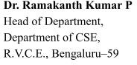**Prof.Mamatha T** Faculty Incharge, Department of CSE,

## R.V.C.E., Bengaluru –59

**RV COLLEGE OF ENGINEERING®, BENGALURU - 560059**

**(Autonomous Institution Affiliated to VTU) DEPARTMENT OF COMPUTER SCIENCE AND ENGINEERING**

DECLARATION

We, **Sanganbasava S C (1RV17CS111)** the students of Seventh Semester B.E., Computer Science and Engineering, R.V. College of Engineering, Bengaluru hereby declare that the mini-project titled **“PATH FINDING GAME”** has been carried out by us and submitted in partial fulfillment for the **Internal Assessment of Course: COMPUTER GRAPHICS LAB (16CS73) - Open-Ended Experiment** during the year 2020-2021. We do declare that the matter embodied in this report has not been submitted to any other university or institution for the award of any other degree or diploma.

**Place: Bengaluru SANGANBASAVA**

**Date:**

**ABSTRACT**

The aim of our Project is to Design an animation based game using opengl API.made with Computer Graphics which is an interactive method of pictorial synthesis of the real or imaginary objects from their computer-based models. It is the analysis of scenes or the reconstruction of the models of the 2D and 3D objects from their pictures. These are used today in everyday life be it a replay in Cricket match, Advanced graphics movies or daily weather report display on TV. Each block hides some figure under it. User chooses a block to see the figure if he/she selects the same in the consecutive chance then both blocks get opened.

OpenGL is the software interface to graphics hardware. This interface consists of about numerous commands, which you use to specify the objects and operations needed to produce interactive applications.

OpenGL is designed to work efficiently even if the computer that displays the graphics you create isn’t the computer that runs your graphics program. This might be the call if you work in the networked computer environment where many computers are connected to one another by wires capable of carrying digital data.

PC game developers develop to show how to combine texture, reflections and projected shades all in real time with OpenGL. The program demonstrates the memory block game.

**ACKNOWLEDGMENT**

Any achievement, be it scholastic or otherwise does not depend solely on the individual efforts but on the guidance, encouragement and cooperation of intellectuals, elders and friends. A number of personalities, in their own capacities have helped me in carrying out this project work. I would like to take this opportunity to thank them all.

I deeply express my sincere gratitude to my guide **Dr. Mamatha T**, Associate Professor, Department of CSE, RVCE, Bengaluru, for his able guidance, regular source of encouragement and assistance throughout this project.

I would like to thank **Dr. Ramakanth Kumar P**, Head of Department, Computer Science & Engineering, R.V.C.E, Bengaluru, for his valuable suggestions and expert advice.

First and foremost, I would like to thank **Dr. Subramanya. K. N**, Principal, R.V.C.E, Bengaluru, for his moral support towards completing my project work.

I thank my Parents, and all the Faculty members of Department of Computer Science & Engineering for their constant support and encouragement.

Last, but not the least, I would like to thank my peers and friends who provided me with valuable suggestions to improve my project.

**TABLE OF CONTENTS**

1. Introduction
   1. Computer graphics
   2. OpenGL
      1. OpenGL Graphics architecture
      2. Primitives and attributes
      3. Color, viewing and control functions
   3. Proposed System
      1. Objective of the project
      2. Methodology
      3. Scope
2. Requirements Specifications
   1. Hardware Requirements
   2. Software Requirements
3. System Design and Implementation
   1. Modular Description
   2. Data Flow Diagram
4. Results and Snapshots
5. Conclusion
6. Bibliography
7. APPENDIX A - Source Code
8. **Introduction**
   1. **Computer Graphics**

Computer graphics is the discipline of generating images with the aid of computers. Today, computer graphics is a core technology in digital photography, film, video games, cell phone and computer displays, and many specialized applications. A great deal of specialized hardware and software has been developed, with the displays of most devices being driven by the computer graphics hardware. It is a vast and recently developed area of computer science. The phrase was coined in 1960 by computer graphics researchers Verne Hudson and William Fetter of Boeing. It is often abbreviated as CG, or typically in the context of the film as CGI.

Some topics in computer graphics include user interface design, sprite graphics, rendering, ray tracing, geometry processing, computer animation, vector graphics, 3D modelling, shaders, GPU design, implicit surface visualization, image processing, computational photography, scientific visualization, computational geometry and computer vision, among others. The overall methodology depends heavily on the underlying sciences of geometry, optics, physics, and perception.

Computer graphics is responsible for displaying art and image data effectively and meaningfully to the consumer. It is also used for processing image data received from the physical world. Computer graphics development has had a significant impact on many types of media and has revolutionized animation, movies, advertising, video games, and graphic design in general.

* 1. **OpenGL**
     1. **OpenGL Graphics Architecture**

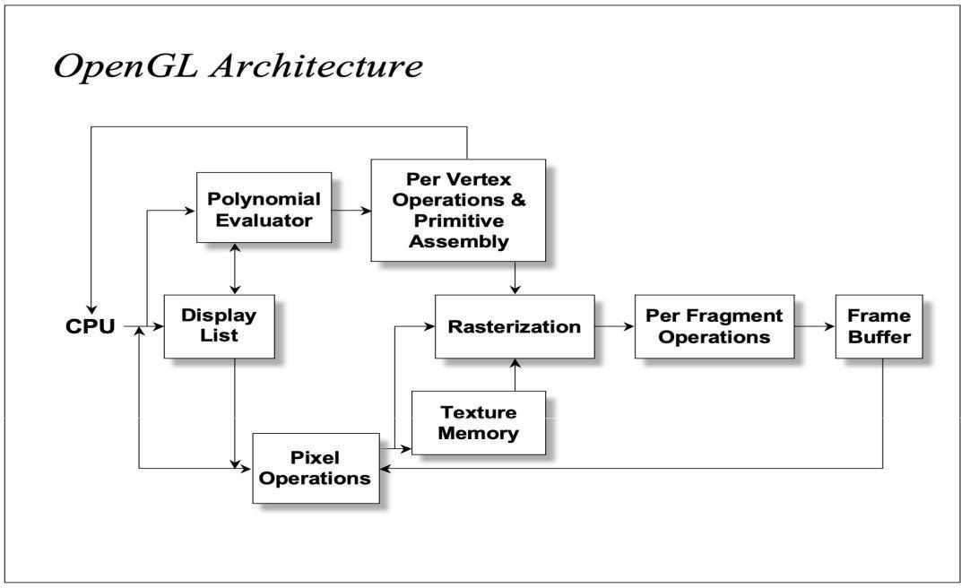

The architecture of OpenGL is based on a client-server model. An application program written to use the OpenGL API is the "client" and runs on the CPU. The implementation of the OpenGL graphics engine is the "server" and runs on the GPU. Geometry and many other types of attributes are stored in buffers called Vertx Buffer Objects. These buffers are allocated on the GPU and filled by your CPU program.

Modelling, rendering, and interaction is very much a cooperative process between the CPU client program and the GPU server programs written in GLSL. An important part of the design process is to decide how best to divide the work and how best to package and communicate the required information from the CPU to the GPU.

* + 1. **Primitives and Attributes**

OpenGL supports several basic primitive types, including points, lines, quadrilaterals, and general polygons. All of these primitives are specified using a sequence of vertices. The diagram below shows the basic primitive types, where the numbers indicate the order in which the vertices have been specified.

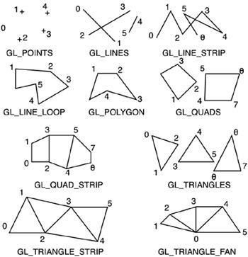

Similarly, for the GL_TRIANGLES primitive, every third vertex causes a triangle to be drawn. Note that for the GL_TRIANGLE_STRIP and GL_TRIANGLE_FAN primitives, a new triangle is produced for every additional vertex. All of the closed primitives shown below are solid-filled, with the exception of GL_LINE_LOOP, which only draws lines connecting the vertices.

In general, a parameter that affects the way a primitive is to be displayed is referred to as an attribute parameter. Some attribute parameters, such as colour and size, determine the fundamental characteristics of a primitive. Other attributes specify how the primitive is to be displayed under special conditions. Text can appear reading from left to right, slanted diagonally across the screen, or in vertical columns. Individual characters can be displayed in different fonts, colours, and sizes. And we can apply intensity variations at the edges of objects to smooth out the raster stair-step effect.

* + 1. **Colour, Viewing and Control Functions**

OpenGL maintains a current drawing colour as part of its state information. The glColor() function calls are used to change the current drawing colour. assigned using the glColor function call. Like glVertex(), this function exists in various instantiations. Colour components are specified in the order of red, green, blue.

Colour component values are in the range [0...1], where 1 corresponds to maximum intensity. For unsigned bytes, the range corresponds to [0...255]. All primitives following the fragment of code given below would be drawn in green, assuming no additional glColor() function calls are used.

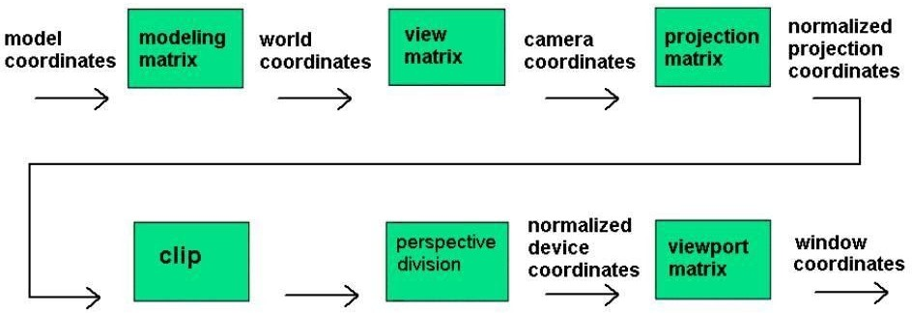

The coordinates we specify using the glVertex* commands are the model coordinates. TheglRotate, glTranslate and glScale commands are used to transform the model into the desired orientation and size. After applying the modelling transformations to the model coordinates what we get are world coordinates. The Modelling transformations give rise to 4×4 matrices.

The control functions are:

Window – A rectangular area of our display.

glutInit allows the application to get command line arguments and initializes the system.

glutInit(int *argc, char **argv) initializes GLUT and processes any command-line arguments (for X, this would be options like -display and -geometry). glutInit() should be called before any other GLUT routine. gluInitDisplayMode requests properties for the window (the rendering context)

* + - * RGB colour
      * Single buffering
      * Properties logically ORed together

glutInitDisplayMode(unsigned int mode) specifies whether to use an RGBA or color index color model. You can also specify whether you want a single- or double-buffered window.

glutInitDisplayMode(GLUT_DOUBLE | GLUT_RGB | GLUT_DEPTH). If you want a window with double buffering, the RGBA colour model, and a depth buffer, you might call

* + - * glutWindowSize(int width, int size) in pixels
      * glutWindowPosition(int x, int y) specifies the screen location for the upper-left corner of your window
      * glutCreateWindow(char *string) create a window with a particular title

**1.2.3 Proposed System**

Our project title is “Implementation of path finding game”. What this means is that we are building a maze of any shape and size and search for a path through it. So, our goal is to create a Perfect Maze. More specifically, the maze we are building is a 2-Dimensional of fixed shape and size, in which the horizontal and vertical walls are connected in such a way, so that the point can move from given starting point to the ending point through the spaces formed by connecting walls, but point should never cross the wall

* + 1. **Objective of the project**

The aim of our Project is to test the accuracy, speed, reaction time and well-defined prediction of the user. Ther will be a perfect maze the with rectangular shape and size which has horizontal and vertical lines . The user has to find the path of the maze in a given time

* + 1. **Methodology**

It contains a rectangular maze of any shape and size in which the horizontal and vertical lines represent the walls of the maze **.**The main working of path finding game is to find out the path from given place to another place by using the movement of point. We use the special key button for the movement of point. The left key button is used to movement of point along  the X-axis as the value decreases, The right key button is used to movement of point along  the X-axis as the value increases, The up key button is used to movement of point along  the y-axis as the value increases, the down key button is used to movement of point along  the y-axis as the value decreases. There is also be given the time limitation, so it is necessary to find out the path within a given time interval.

Arrow Key Up – Move forward

Arrow Key Down – Move backward

Arrow Key Left – Strafe left

Arrow Key Right – Strafe right

ESCAPE - MENU

* + 1. **Scope**

It is the basic implementation of the classic game The path finding game. It is created by using minimum classes and functions. OpenGL has been used effectively for all the animation without the use of any additional libraries. This allows for the creation and implementation of many other games using only OpenGL.

1. **Requirement Specifications**
   1. **Hardware Requirements**
      * + Monitor
        + Keyboard
        + Mouse
        + CPU
   2. **Software Requirements**
      * + Linux or MacOS
        + OpenGL
        + XCode
        + GCC
        + G++
        + OpenGL Utility Toolkit
2. **System Design and Implementation**

In this project we have created a game using “OpenGL” functional API. We have taken the help of built in functions present in the header file. To provide functionality to our project we have written sub functions. These functions provide us the efficient way to design the project. In this chapter we are describing the functionality of our project using these functions.

In our project we are mainly concentrating on primitives like triangle and rectangle. By using keyboard interactions, we can play the game.

* + - * **Startup:** Press Key ‘Enter’ to initiate the game
      * **Navigation:** Right Click, Choose the game options start the game ,instruction or exit
      * **Quit:** Press Esc key to quit the game.
  1. **Modular Description:**
* **void point()** function to draw the point that moves.
* **void output(int x, int y, char *string)**:Module to show the output.
* **void drawstring(int x, int y, char *string,void *font)**: Module to show the written output
* **void frontscreen(void)**:Module to display front screen.
* **void winscreen()** : Module to display after winning screen.
* **void instructions() :** Module to show the instructions to user.
* **void wall(GLfloat x1,GLfloat y1,GLfloat x2,GLfloat y2,GLfloat x3,GLfloat y3,GLfloat x4,GLfloat y4) :** Module to draw the walls.
* **void SpecialKey(int key, int x, int y) :** Module for tracking movement of the point.
* **void display() :** Module for display of the output
* **void keyboard(unsigned char key,int x,int y) :** Module to receive input from the keyboard..
* **void idle()**: Handles the motion of the ball along with rebounding from various surfaces.
* **int main (int argc,char **argv):** Main function

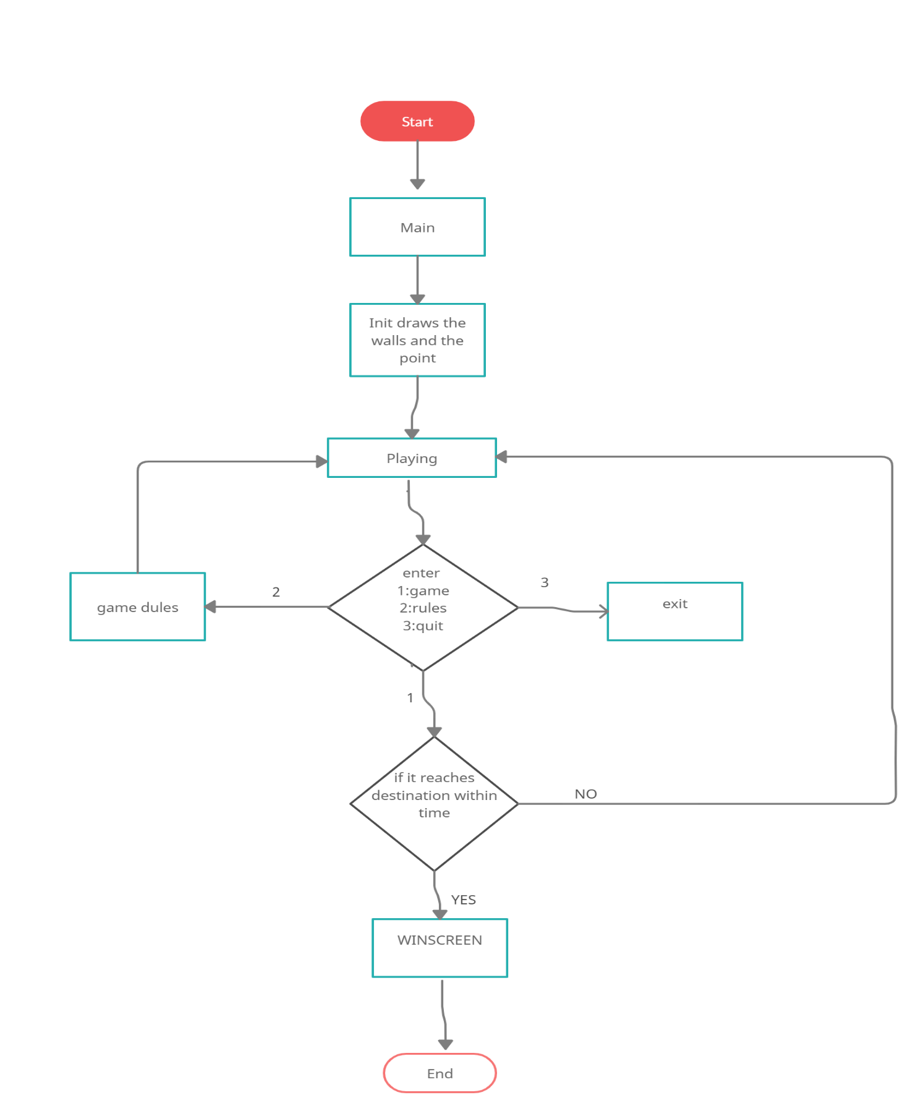

3.2 DATA FLOW DIAGRAM

**Results and Snapshots**

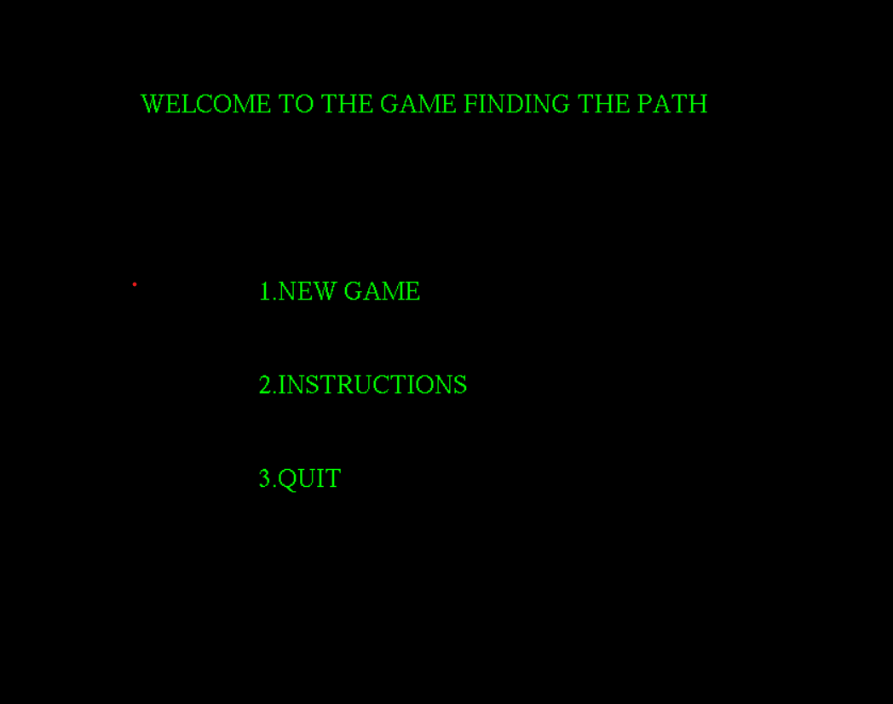

**Fig 5.1: Beginning of the game**

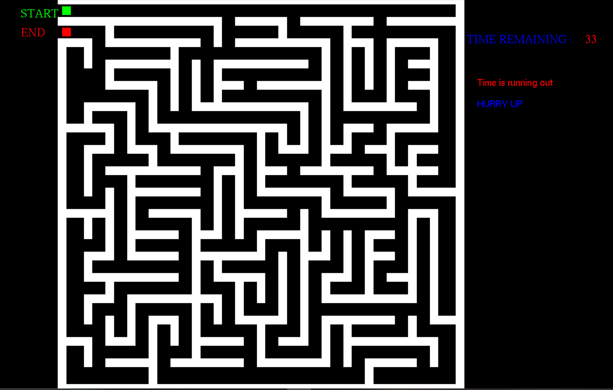

FIG 5.2 GAME SCREEN

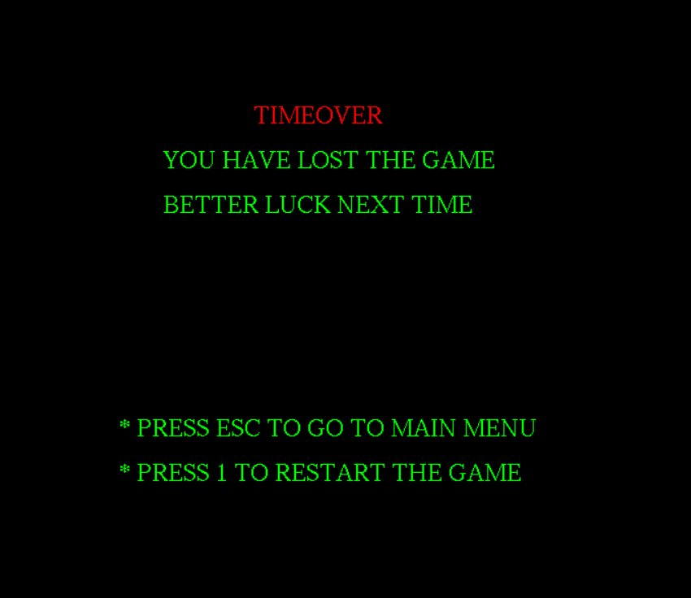

FIG 5.3 WINNING SCREEN

1. **Conclusion**

As the project was progressive in nature, we learnt about gaming using computer graphics. It also helped us to understand various inbuilt functions of OpenGL. The keyboard interaction has helped us to implement this project in an easier way .As the project work was progressive in nature, and OpenGL methodology was employed, we obtain a good experience in OpenGL software development.

1. **Bibliography Textbooks**

* Computer Graphics with OpenGL, Donald D. Hearn, M. Pauline Baker, Warren Carithers, 4th Edition, 2010, Pearson Education, ISBN-13: 978-0136053583.
* Interactive Computer Graphics: A Top-Down Approach Using OpenGL, Edward Angel, 5th Edition, 2010, Pearson Education, ISBN: 978131725306.
* Computer Graphics, Zhigang Xiang and Roy Plastock, 2nd Edition, 2007, ASIN: 0070601658, Tata McGraw-Hill, ISBN-13: 978-0070601659

**External Links**

* <https://www.opengl.org/>
* <https://www.tutorialspoint.com/listtutorial/Introduction-to-OpenGL/2339>
* https://learnopengl.com/Introduction

**Appendix A - Source Code**

/*

* Path finding game
* Authors: Sanganbasava
* Computer Graphics Mini Project

*/

#include<stdio.h>

#include<stdlib.h>

#include<GL/glut.h>

#include<math.h>

#include<string.h>

#include<time.h>

int x,y;

int i,count;

char t[2];

float px=0.0,py=175.0;

int flag, df=10;

clock_t start,end;

void point()

{

glColor3f(0.0,0.0,1.0);

glBegin(GL_POINTS);

glVertex2f(px,py);

glEnd();

}

void point1()

{

glColor3f(.0,1.0,0.0);

glBegin(GL_POINTS);

glVertex2f(0.0,175.0);

glEnd();

}

void point2()

{

glColor3f(1.0,0.0,.0);

glBegin(GL_POINTS);

glVertex2f(0.0,165.0);

glEnd();

}

void output(int x, int y, char *string)

{

int len, i;

glRasterPos2f(x,y);

len=(int) strlen(string);

for (i = 0; i < len; i++)

{

glutBitmapCharacter(GLUT_BITMAP_TIMES_ROMAN_24,string[i]);

}

}

void drawstring(int x, int y, char *string,void *font)

{

int len, i;

glRasterPos2f(x,y);

len=(int) strlen(string);

for (i = 0; i < len; i++)

{

glutBitmapCharacter(font,string[i]);

}

}

void frontscreen(void)

{

glClear(GL_COLOR_BUFFER_BIT);

glLoadIdentity();

glColor3f(1,1,1);

drawstring(120,5," Press ENTER to go To next screen",GLUT_BITMAP_HELVETICA_18);

drawstring(-45,5,"Maximize window for better view",GLUT_BITMAP_HELVETICA_12);

glColor3f(1,1,1);

output(5,160,"RV COLLEGE OF ENGINEERING");

glColor3f(1,1,1);

output(10.0,150,"DEPARTMENT OF COMPUTER SCIENCE AND ENGINEERING");

glColor3f(1,0,1);

output(60,130,"A Mini Project On:-");

glColor3f(0,1,0.5);

output(38,120,"\"PATH FINDING USING OPENGL\"");

glColor3f(1,0,1);

output(40,100,"By :");

glBegin(GL_LINES);

glVertex2f(40,98);

glVertex2f(50,98);

glEnd();

glColor3f(1,0,0);

output(40,90,"SANGANBASAVA ");

//output(70,20,"Mr.Rony joseph,Dept. of CSE");

glFlush();

}

void winscreen()

{

glClear(GL_COLOR_BUFFER_BIT);

glLoadIdentity();

glColor3f(0.0,1.0,0.0);

output(55,120,"CONGRATS!!!");

glColor3f(1.0,0.0,1.0);

output(15,100,"YOU HAVE SUCCEEDED IN FINDING OUT THE PATH");

output(35,60,"* PRESS ESC TO GO TO MAIN MENU");

output(35,45,"* PRESS 1 TO RESTART THE GAME");

glFlush();

}

void startscreen()

{

glClear(GL_COLOR_BUFFER_BIT);

glColor3f(0.0,1.0,0.0);

output(25,140,"WELCOME TO THE GAME FINDING THE PATH");

output(50,100,"1.NEW GAME");

output(50,80,"2.INSTRUCTIONS");

output(50,60,"3.QUIT");

glFlush();

}

void instructions()

{

glClear(GL_COLOR_BUFFER_BIT);

glColor3f(1.0,1.0,0.0);

output(45,140,"INSTRUCTIONS:");

glBegin(GL_LINES);

glVertex2f(45,138);

glVertex2f(90,138);

glEnd();

glColor3f(0,1,0);

output(-20,120,"* TO MOVE THE POINT USE ARROW KEYS");

output(-20,100,"* FIND THE WAY TO MOVE INTO THE MAZE AND GET OUT");

output(-20,80,"* GREEN COLOURED POINT INDICATE THE POINT FROM WHERE YOU HAVE TO START");

output(-20,60,"* RED COLOURED POINT INDICATE THE POINT WHERE YOU HAVE TO REACH");

output(-20,40,"* YOU WILL HAVE TO HURRY AS YOU HAVE LIMITED TIME");

output(-20,20,"* PRESS ESC TO GO TO MAIN MENU");

glFlush();

}

void timeover()

{

glClear(GL_COLOR_BUFFER_BIT);

glColor3f(1.0,0,0);

output(70,110,"TIMEOVER");

glColor3f(0,1,0);

output(50,100,"YOU HAVE LOST THE GAME");

output(50,90,"BETTER LUCK NEXT TIME");

output(40,40,"* PRESS ESC TO GO TO MAIN MENU");

output(40,30,"* PRESS 1 TO RESTART THE GAME");

glFlush();

}

void idle()

{

if(df==1)

{

end=clock();

count=(end-start)/CLOCKS_PER_SEC;

if(count==60)

{

df=4;

}

else

if((count<60) && ((px>=0 && px<=4) && (py>=162 && py<=168)))

{

df=5;

}

}

glutPostRedisplay();

}

void wall(GLfloat x1,GLfloat y1,GLfloat x2,GLfloat y2,GLfloat x3,GLfloat y3,GLfloat x4,GLfloat y4)

{

glBegin(GL_POLYGON);

glVertex3f(x1,y1,0);

glVertex3f(x2,y2,0);

glVertex3f(x3,y3,0);

glVertex3f(x4,y4,0);

glEnd();

}

void SpecialKey(int key, int x, int y)

{

switch (key)

{

case GLUT_KEY_UP:

flag=0;

if(py<175)

if(!((px>=8 && px<=12) && (py>=145 && py<=162)))

if(!((px>=168 && px<=172) && (py>=5 && py<=22)))

if(!((px>=132 && px<=172) && (py>=15 && py<=22)))

if(!((px>=128 && px<=132) && (py>=5 && py<=32)))

if(!((px>=142 && px<=162) && (py>=5 && py<=12)))

if(!((px>=118 && px<=152) && (py>=25 && py<=32)))

if(!((px>=88 && px<=122) && (py>=5 && py<=12)))

if(!((px>=48 && px<=82) && (py>=5 && py<=12)))

if(!((px>=62 && px<=82) && (py>=15 && py<=22)))

if(!((px>=8 && px<=12) && (py>=5 && py<=18)))

if(!((px>=0 && px<=12) && (py>=15 && py<=22)))

if(!((px>=42 && px<=52) && (py>=25 && py<=32)))

if(!((px>=18 && px<=42) && (py>=5 && py<=12)))

if(!((px>=0 && px<=8) && (py>=155 && py<=162)))

if(!((px>=0 && px<=72) && (py>=165 && py<=172)))

if(!((px>=18 && px<=62) && (py>=155 && py<=162)))

if(!((px>=48 && px<=52) && (py>=125 && py<=158)))

if(!((px>=18 && px<=48) && (py>=145 && py<=152)))

if(!((px>=18 && px<=38) && (py>=135 && py<=142)))

if(!((px>=68 && px<=112) && (py>=145 && py<=152)))

if(!((px>=88 && px<=118) && (py>=135 && py<=142)))

if(!((px>=132 && px<=138) && (py>=155 && py<=162)))

if(!((px>=138 && px<=142) && (py>=135 && py<=162)))

if(!((px>=128 && px<=162) && (py>=125 && py<=132)))

if(!((px>=78 && px<=122) && (py>=155 && py<=162)))

if(!((px>=78 && px<=102) && (py>=165 && py<=172)))

if(!((px>=108 && px<=142) && (py>=165 && py<=172)))

if(!((px>=148 && px<=180) && (py>=165 && py<=172)))

if(!((px>=138 && px<=152) && (py>=65 && py<=72)))

if(!((px>=148 && px<=172) && (py>=155 && py<=162)))

if(!((px>=148 && px<=172) && (py>=165 && py<=172)))

if(!((px>=148 && px<=172) && (py>=95 && py<=102)))

if(!((px>=158 && px<=168) && (py>=145 && py<=152)))

if(!((px>=158 && px<=168) && (py>=135 && py<=142)))

if(!((px>=168 && px<=172) && (py>=119 && py<=162)))

if(!((px>=152 && px<=172) && (py>=115 && py<=122)))

if(!((px>=138 && px<=148) && (py>=105 && py<=112)))

if(!((px>=148 && px<=152) && (py>=95 && py<=122)))

if(!((px>=158 && px<=172) && (py>=105 && py<=112)))

if(!((px>=162 && px<=172) && (py>=105 && py<=112)))

if(!((px>=158 && px<=162) && (py>=89 && py<=112)))

if(!((px>=158 && px<=180) && (py>=85 && py<=92)))

if(!((px>=132 && px<=142) && (py>=115 && py<=122)))

if(!((px>=128 && px<=132) && (py>=109 && py<=122)))

if(!((px>=122 && px<=132) && (py>=105 && py<=112)))

if(!((px>=118 && px<=122) && (py>=99 && py<=162)))

if(!((px>=108 && px<=142) && (py>=95 && py<=102)))

if(!((px>=128 && px<=132) && (py>=89 && py<=98)))

if(!((px>=128 && px<=152) && (py>=85 && py<=92)))

if(!((px>=148 && px<=152) && (py>=79 && py<=88)))

if(!((px>=118 && px<=152) && (py>=75 && py<=82)))

if(!((px>=92 && px<=122) && (py>=85 && py<=92)))

if(!((px>=92 && px<=102) && (py>=95 && py<=102)))

if(!((px>=118 && px<=122) && (py>=75 && py<=88)))

if(!((px>=88 && px<=92) && (py>=85 && py<=118)))

if(!((px>=58 && px<=62) && (py>=125 && py<=152)))

if(!((px>=108 && px<=112) && (py>=109 && py<=128)))

if(!((px>=58 && px<=112) && (py>=125 && py<=132)))

if(!((px>=98 && px<=102) && (py>=109 && py<=118)))

if(!((px>=48 && px<=52) && (py>=15 && py<=32)))

if(!((px>=32 && px<=42) && (py>=105 && py<=112)))

if(!((px>=12 && px<=28) && (py>=125 && py<=132)))

if(!((px>=28 && px<=32) && (py>=105 && py<=132)))

if(!((px>=8 && px<=12) && (py>=119 && py<=132)))

if(!((px>=0 && px<=22) && (py>=115 && py<=122)))

if(!((px>=18 && px<=22) && (py>=109 && py<=122)))

if(!((px>=12 && px<=22) && (py>=105 && py<=112)))

if(!((px>=8 && px<=12) && (py>=85 && py<=112)))

if(!((px>=98 && px<=112) && (py>=105 && py<=112)))

if(!((px>=38 && px<=102) && (py>=115 && py<=122)))

if(!((px>=48 && px<=52) && (py>=109 && py<=118)))

if(!((px>=48 && px<=78) && (py>=105 && py<=112)))

if(!((px>=82 && px<=102) && (py>=75 && py<=82)))

if(!((px>=78 && px<=82) && (py>=65 && py<=112)))

if(!((px>=72 && px<=78) && (py>=95 && py<=102)))

if(!((px>=62 && px<=72) && (py>=65 && py<=72)))

if(!((px>=28 && px<=32) && (py>=119 && py<=152)))

if(!((px>=92 && px<=108) && (py>=65 && py<=72)))

if(!((px>=88 && px<=92) && (py>=59 && py<=72)))

if(!((px>=62 && px<=92) && (py>=55 && py<=62)))

if(!((px>=38 && px<=58) && (py>=75 && py<=82)))

if(!((px>=68 && px<=72) && (py>=45 && py<=62)))

if(!((px>=8 && px<=12) && (py>=65 && py<=82)))

if(!((px>=32 && px<=62) && (py>=85 && py<=92)))

if(!((px>=28 && px<=52) && (py>=65 && py<=72)))

if(!((px>=32 && px<=52) && (py>=55 && py<=62)))

if(!((px>=28 && px<=32) && (py>=55 && py<=98)))

if(!((px>=18 && px<=62) && (py>=95 && py<=102)))

if(!((px>=0 && px<=18) && (py>=75 && py<=82)))

if(!((px>=18 && px<=22) && (py>=59 && py<=92)))

if(!((px>=12 && px<=22) && (py>=55 && py<=62)))

if(!((px>=8 && px<=52) && (py>=45 && py<=52)))

if(!((px>=18 && px<=22) && (py>=39 && py<=48)))

if(!((px>=12 && px<=22) && (py>=35 && py<=42)))

if(!((px>=8 && px<=12) && (py>=25 && py<=42)))

if(!((px>=118 && px<=122) && (py>=59 && py<=72)))

if(!((px>=112 && px<=122) && (py>=55 && py<=62)))

if(!((px>=138 && px<=152) && (py>=55 && py<=62)))

if(!((px>=148 && px<=158) && (py>=45 && py<=52)))

if(!((px>=138 && px<=142) && (py>=39 && py<=72)))

if(!((px>=128 && px<=132) && (py>=49 && py<=72)))

if(!((px>=122 && px<=132) && (py>=45 && py<=52)))

if(!((px>=118 && px<=122) && (py>=35 && py<=52)))

if(!((px>=118 && px<=158) && (py>=35 && py<=42)))

if(!((px>=158 && px<=162) && (py>=35 && py<=78)))

if(!((px>=158 && px<=168) && (py>=75 && py<=82)))

if(!((px>=168 && px<=172) && (py>=29 && py<=82)))

if(!((px>=168 && px<=180) && (py>=25 && py<=32)))

if(!((px>=98 && px<=108) && (py>=15 && py<=22)))

if(!((px>=108 && px<=112) && (py>=15 && py<=82)))

if(!((px>=88 && px<=92) && (py>=35 && py<=48)))

if(!((px>=68 && px<=92) && (py>=45 && py<=52)))

if(!((px>=98 && px<=102) && (py>=29 && py<=62)))

if(!((px>=78 && px<=82) && (py>=25 && py<=48)))

if(!((px>=68 && px<=72) && (py>=25 && py<=38)))

if(!((px>=32 && px<=72) && (py>=35 && py<=42)))

if(!((px>=22 && px<=32) && (py>=19 && py<=22)))

if(!((px>=22 && px<=32) && (py>=15 && py<=22)))

if(!((px>=18 && px<=22) && (py>=15 && py<=32)))

if(!((px>=78 && px<=102) && (py>=25 && py<=32)))

if(!((px>=88 && px<=92) && (py>=9 && py<=28)))

py=py+5;

glutPostRedisplay();

break;

case GLUT_KEY_DOWN:

flag=0;

if(py>5)

if(!((px>=0 && px<=8) && (py>=158 && py<=165)))

if(!((px>=8 && px<=12) && (py>=148 && py<=165)))

if(!((px>=0 && px<=72) && (py>=168 && py<=175)))

if(!((px>=18 && px<=62) && (py>=158 && py<=165)))

if(!((px>=18 && px<=48) && (py>=148 && py<=155)))

if(!((px>=18 && px<=38) && (py>=138 && py<=145)))

if(!((px>=72 && px<=82) && (py>=138 && py<=145)))

if(!((px>=68 && px<=112) && (py>=148 && py<=155)))

if(!((px>=88 && px<=118) && (py>=138 && py<=145)))

if(!((px>=132 && px<=138) && (py>=158 && py<=165)))

if(!((px>=138 && px<=152) && (py>=68 && py<=75)))

if(!((px>=108 && px<=142) && (py>=168 && py<=175)))

if(!((px>=128 && px<=162) && (py>=128 && py<=135)))

if(!((px>=68 && px<=72) && (py>=158 && py<=175)))

if(!((px>=78 && px<=122) && (py>=158 && py<=165)))

if(!((px>=78 && px<=102) && (py>=168 && py<=175)))

if(!((px>=148 && px<=180) && (py>=168 && py<=175)))

if(!((px>=148 && px<=172) && (py>=158 && py<=165)))

if(!((px>=148 && px<=172) && (py>=168 && py<=175)))

if(!((px>=148 && px<=172) && (py>=98 && py<=105)))

if(!((px>=158 && px<=168) && (py>=148 && py<=155)))

if(!((px>=158 && px<=168) && (py>=138 && py<=145)))

if(!((px>=148 && px<=172) && (py>=118 && py<=125)))

if(!((px>=138 && px<=148) && (py>=108 && py<=115)))

if(!((px>=158 && px<=172) && (py>=108 && py<=115)))

if(!((px>=162 && px<=172) && (py>=108 && py<=115)))

if(!((px>=158 && px<=180) && (py>=88 && py<=95)))

if(!((px>=132 && px<=142) && (py>=118 && py<=125)))

if(!((px>=122 && px<=132) && (py>=108 && py<=115)))

if(!((px>=108 && px<=142) && (py>=98 && py<=105)))

if(!((px>=128 && px<=152) && (py>=88 && py<=95)))

if(!((px>=118 && px<=152) && (py>=78 && py<=85)))

if(!((px>=92 && px<=122) && (py>=88 && py<=95)))

if(!((px>=92 && px<=102) && (py>=98 && py<=105)))

if(!((px>=118 && px<=152) && (py>=28 && py<=35)))

if(!((px>=88 && px<=92) && (py>=88 && py<=121)))

if(!((px>=58 && px<=62) && (py>=128 && py<=155)))

if(!((px>=108 && px<=112) && (py>=112 && py<=131)))

if(!((px>=58 && px<=112) && (py>=128 && py<=135)))

if(!((px>=98 && px<=102) && (py>=112 && py<=121)))

if(!((px>=38 && px<=42) && (py>=102 && py<=115)))

if(!((px>=32 && px<=42) && (py>=108 && py<=115)))

if(!((px>=12 && px<=28) && (py>=128 && py<=135)))

if(!((px>=28 && px<=32) && (py>=108 && py<=135)))

if(!((px>=8 && px<=12) && (py>=122 && py<=135)))

if(!((px>=0 && px<=22) && (py>=118 && py<=125)))

if(!((px>=18 && px<=22) && (py>=112 && py<=125)))

if(!((px>=12 && px<=22) && (py>=108 && py<=115)))

if(!((px>=8 && px<=12) && (py>=88 && py<=115)))

if(!((px>=98 && px<=112) && (py>=108 && py<=115)))

if(!((px>=38 && px<=102) && (py>=118 && py<=125)))

if(!((px>=48 && px<=52) && (py>=112 && py<=118)))

if(!((px>=48 && px<=78) && (py>=108 && py<=115)))

if(!((px>=82 && px<=102) && (py>=78 && py<=85)))

if(!((px>=78 && px<=82) && (py>=68 && py<=115)))

if(!((px>=72 && px<=78) && (py>=98 && py<=105)))

if(!((px>=68 && px<=72) && (py>=72 && py<=105)))

if(!((px>=62 && px<=72) && (py>=68 && py<=75)))

if(!((px>=28 && px<=32) && (py>=122 && py<=155)))

if(!((px>=92 && px<=108) && (py>=68 && py<=75)))

if(!((px>=88 && px<=92) && (py>=62 && py<=75)))

if(!((px>=62 && px<=92) && (py>=58 && py<=65)))

if(!((px>=38 && px<=58) && (py>=78 && py<=85)))

if(!((px>=68 && px<=72) && (py>=48 && py<=65)))

if(!((px>=8 && px<=12) && (py>=68 && py<=85)))

if(!((px>=32 && px<=62) && (py>=88 && py<=95)))

if(!((px>=28 && px<=52) && (py>=68 && py<=75)))

if(!((px>=32 && px<=52) && (py>=58 && py<=65)))

if(!((px>=28 && px<=32) && (py>=58 && py<=101)))

if(!((px>=18 && px<=62) && (py>=98 && py<=105)))

if(!((px>=0 && px<=18) && (py>=78 && py<=85)))

if(!((px>=18 && px<=22) && (py>=62 && py<=95)))

if(!((px>=12 && px<=22) && (py>=58 && py<=65)))

if(!((px>=8 && px<=12) && (py>=52 && py<=65)))

if(!((px>=8 && px<=52) && (py>=48 && py<=55)))

if(!((px>=18 && px<=22) && (py>=42 && py<=51)))

if(!((px>=12 && px<=22) && (py>=38 && py<=45)))

if(!((px>=8 && px<=12) && (py>=28 && py<=45)))

if(!((px>=118 && px<=122) && (py>=62 && py<=75)))

if(!((px>=112 && px<=122) && (py>=58 && py<=65)))

if(!((px>=142 && px<=152) && (py>=58 && py<=65)))

if(!((px>=148 && px<=158) && (py>=48 && py<=55)))

if(!((px>=138 && px<=142) && (py>=42 && py<=75)))

if(!((px>=128 && px<=132) && (py>=52 && py<=75)))

if(!((px>=122 && px<=132) && (py>=48 && py<=55)))

if(!((px>=118 && px<=122) && (py>=38 && py<=55)))

if(!((px>=118 && px<=158) && (py>=38 && py<=45)))

if(!((px>=158 && px<=162) && (py>=38 && py<=78)))

if(!((px>=158 && px<=168) && (py>=78 && py<=85)))

if(!((px>=168 && px<=172) && (py>=32 && py<=85)))

if(!((px>=168 && px<=180) && (py>=28 && py<=35)))

if(!((px>=98 && px<=108) && (py>=18 && py<=25)))

if(!((px>=108 && px<=112) && (py>=18 && py<=85)))

if(!((px>=88 && px<=92) && (py>=38 && py<=53)))

if(!((px>=68 && px<=92) && (py>=48 && py<=55)))

if(!((px>=98 && px<=102) && (py>=32 && py<=65)))

if(!((px>=78 && px<=82) && (py>=28 && py<=53)))

if(!((px>=68 && px<=72) && (py>=28 && py<=43)))

if(!((px>=32 && px<=72) && (py>=38 && py<=45)))

if(!((px>=28 && px<=32) && (py>=18 && py<=45)))

if(!((px>=22 && px<=32) && (py>=18 && py<=25)))

if(!((px>=18 && px<=22) && (py>=18 && py<=35)))

if(!((px>=78 && px<=102) && (py>=28 && py<=35)))

if(!((px>=88 && px<=92) && (py>=12 && py<=31)))

if(!((px>=118 && px<=122) && (py>=8 && py<=35)))

if(!((px>=158 && px<=162) && (py>=22 && py<=35)))

if(!((px>=168 && px<=172) && (py>=8 && py<=25)))

if(!((px>=132 && px<=172) && (py>=18 && py<=25)))

if(!((px>=128 && px<=132) && (py>=8 && py<=35)))

if(!((px>=142 && px<=162) && (py>=8 && py<=15)))

if(!((px>=138 && px<=142) && (py>=0 && py<=15)))

if(!((px>=88 && px<=122) && (py>=8 && py<=15)))

if(!((px>=48 && px<=82) && (py>=8 && py<=15)))

if(!((px>=62 && px<=82) && (py>=18 && py<=25)))

if(!((px>=8 && px<=12) && (py>=8 && py<=21)))

if(!((px>=0 && px<=12) && (py>=18 && py<=25)))

if(!((px>=58 && px<=62) && (py>=8 && py<=85)))

if(!((px>=48 && px<=52) && (py>=18 && py<=31)))

if(!((px>=42 && px<=52) && (py>=28 && py<=35)))

if(!((px>=38 && px<=42) && (py>=0 && py<=35)))

if(!((px>=18 && px<=42) && (py>=8 && py<=15)))

py=py-5;

glutPostRedisplay();

break;

case GLUT_KEY_LEFT:

flag=0;

if(px>0)

if(!((px>=8 && px<=15) && (py>=148 && py<=162)))

if(!((px>=68 && px<=75) && (py>=158 && py<=168)))

if(!((px>=138 && px<=155) && (py>=68 && py<=72)))

if(!((px>=18 && px<=25) && (py>=162 && py<=168)))

if(!((px>=18 && px<=65) && (py>=58 && py<=62)))

if(!((px>=48 && px<=55) && (py>=128 && py<=158)))

if(!((px>=18 && px<=25) && (py>=142 && py<=148)))

if(!((px>=38 && px<=45) && (py>=122 && py<=142)))

if(!((px>=72 && px<=85) && (py>=138 && py<=142)))

if(!((px>=68 && px<=75) && (py>=132 && py<=148)))

if(!((px>=68 && px<=115) && (py>=148 && py<=152)))

if(!((px>=138 && px<=145) && (py>=138 && py<=162)))

if(!((px>=18 && px<=145) && (py>=168 && py<=172)))

if(!((px>=128 && px<=135) && (py>=132 && py<=172)))

if(!((px>=128 && px<=165) && (py>=128 && py<=132)))

if(!((px>=68 && px<=75) && (py>=158 && py<=172)))

if(!((px>=78 && px<=125) && (py>=158 && py<=162)))

if(!((px>=98 && px<=105) && (py>=162 && py<=172)))

if(!((px>=78 && px<=105) && (py>=168 && py<=172)))

if(!((px>=108 && px<=145) && (py>=168 && py<=172)))

if(!((px>=148 && px<=180) && (py>=168 && py<=172)))

if(!((px>=148 && px<=155) && (py>=132 && py<=162)))

if(!((px>=148 && px<=175) && (py>=158 && py<=162)))

if(!((px>=148 && px<=175) && (py>=168 && py<=172)))

if(!((px>=148 && px<=175) && (py>=98 && py<=102)))

if(!((px>=168 && px<=175) && (py>=122 && py<=162)))

if(!((px>=152 && px<=175) && (py>=118 && py<=122)))

if(!((px>=148 && px<=155) && (py>=98 && py<=122)))

if(!((px>=158 && px<=175) && (py>=108 && py<=112)))

if(!((px>=162 && px<=175) && (py>=108 && py<=112)))

if(!((px>=158 && px<=165) && (py>=92 && py<=112)))

if(!((px>=158 && px<=180) && (py>=88 && py<=92)))

if(!((px>=132 && px<=145) && (py>=118 && py<=122)))

if(!((px>=128 && px<=135) && (py>=112 && py<=122)))

if(!((px>=122 && px<=135) && (py>=108 && py<=112)))

if(!((px>=118 && px<=125) && (py>=102 && py<=162)))

if(!((px>=108 && px<=145) && (py>=98 && py<=102)))

if(!((px>=128 && px<=135) && (py>=92 && py<=98)))

if(!((px>=128 && px<=155) && (py>=88 && py<=92)))

if(!((px>=148 && px<=155) && (py>=82 && py<=88)))

if(!((px>=118 && px<=155) && (py>=78 && py<=82)))

if(!((px>=92 && px<=125) && (py>=88 && py<=92)))

if(!((px>=92 && px<=105) && (py>=98 && py<=102)))

if(!((px>=118 && px<=125) && (py>=78 && py<=88)))

if(!((px>=88 && px<=95) && (py>=88 && py<=118)))

if(!((px>=58 && px<=65) && (py>=128 && py<=152)))

if(!((px>=108 && px<=115) && (py>=112 && py<=128)))

if(!((px>=58 && px<=115) && (py>=128 && py<=132)))

if(!((px>=98 && px<=105) && (py>=112 && py<=118)))

if(!((px>=38 && px<=45) && (py>=102 && py<=108)))

if(!((px>=32 && px<=45) && (py>=108 && py<=112)))

if(!((px>=28 && px<=35) && (py>=108 && py<=132)))

if(!((px>=8 && px<=15) && (py>=122 && py<=132)))

if(!((px>=0 && px<=25) && (py>=118 && py<=122)))

if(!((px>=18 && px<=25) && (py>=112 && py<=122)))

if(!((px>=12 && px<=25) && (py>=108 && py<=112)))

if(!((px>=8 && px<=15) && (py>=88 && py<=112)))

if(!((px>=98 && px<=115) && (py>=108 && py<=112)))

if(!((px>=38 && px<=105) && (py>=118 && py<=122)))

if(!((px>=48 && px<=55) && (py>=112 && py<=118)))

if(!((px>=82 && px<=105) && (py>=78 && py<=82)))

if(!((px>=78 && px<=85) && (py>=68 && py<=112)))

if(!((px>=68 && px<=75) && (py>=72 && py<=102)))

if(!((px>=62 && px<=75) && (py>=68 && py<=72)))

if(!((px>=28 && px<=35) && (py>=108 && py<=132)))

if(!((px>=88 && px<=95) && (py>=62 && py<=72)))

if(!((px>=62 && px<=95) && (py>=58 && py<=62)))

if(!((px>=68 && px<=75) && (py>=48 && py<=62)))

if(!((px>=8 && px<=15) && (py>=68 && py<=82)))

if(!((px>=32 && px<=65) && (py>=88 && py<=92)))

if(!((px>=28 && px<=55) && (py>=68 && py<=72)))

if(!((px>=32 && px<=55) && (py>=58 && py<=62)))

if(!((px>=28 && px<=35) && (py>=58 && py<=98)))

if(!((px>=18 && px<=65) && (py>=98 && py<=102)))

if(!((px>=18 && px<=25) && (py>=62 && py<=92)))

if(!((px>=12 && px<=25) && (py>=58 && py<=62)))

if(!((px>=8 && px<=15) && (py>=52 && py<=62)))

if(!((px>=8 && px<=55) && (py>=48 && py<=52)))

if(!((px>=18 && px<=25) && (py>=42 && py<=48)))

if(!((px>=12 && px<=25) && (py>=38 && py<=42)))

if(!((px>=8 && px<=15) && (py>=28 && py<=42)))

if(!((px>=118 && px<=125) && (py>=62 && py<=72)))

if(!((px>=112 && px<=125) && (py>=58 && py<=62)))

if(!((px>=142 && px<=155) && (py>=58 && py<=62)))

if(!((px>=138 && px<=145) && (py>=42 && py<=72)))

if(!((px>=128 && px<=135) && (py>=52 && py<=72)))

if(!((px>=122 && px<=135) && (py>=48 && py<=52)))

if(!((px>=118 && px<=125) && (py>=38 && py<=52)))

if(!((px>=118 && px<=155) && (py>=28 && py<=32)))

if(!((px>=158 && px<=165) && (py>=38 && py<=78)))

if(!((px>=168 && px<=175) && (py>=32 && py<=82)))

if(!((px>=168 && px<=180) && (py>=28 && py<=32)))

if(!((px>=98 && px<=108) && (py>=18 && py<=22)))

if(!((px>=108 && px<=115) && (py>=18 && py<=82)))

if(!((px>=88 && px<=95) && (py>=38 && py<=48)))

if(!((px>=68 && px<=95) && (py>=48 && py<=52)))

if(!((px>=98 && px<=105) && (py>=32 && py<=62)))

if(!((px>=78 && px<=85) && (py>=28 && py<=48)))

if(!((px>=68 && px<=75) && (py>=28 && py<=38)))

if(!((px>=32 && px<=75) && (py>=38 && py<=42)))

if(!((px>=28 && px<=35) && (py>=22 && py<=42)))

if(!((px>=22 && px<=35) && (py>=18 && py<=22)))

if(!((px>=18 && px<=25) && (py>=18 && py<=32)))

if(!((px>=78 && px<=105) && (py>=28 && py<=32)))

if(!((px>=88 && px<=95) && (py>=12 && py<=28)))

if(!((px>=118 && px<=125) && (py>=8 && py<=32)))

if(!((px>=158 && px<=165) && (py>=22 && py<=32)))

if(!((px>=168 && px<=175) && (py>=8 && py<=22)))

if(!((px>=132 && px<=175) && (py>=18 && py<=22)))

if(!((px>=128 && px<=135) && (py>=8 && py<=32)))

if(!((px>=142 && px<=165) && (py>=8 && py<=12)))

if(!((px>=138 && px<=145) && (py>=0 && py<=12)))

if(!((px>=88 && px<=125) && (py>=8 && py<=12)))

if(!((px>=48 && px<=85) && (py>=8 && py<=12)))

if(!((px>=62 && px<=85) && (py>=18 && py<=22)))

if(!((px>=8 && px<=15) && (py>=8 && py<=18)))

if(!((px>=0 && px<=15) && (py>=18 && py<=22)))

if(!((px>=58 && px<=65) && (py>=8 && py<=82)))

if(!((px>=48 && px<=55) && (py>=18 && py<=28)))

if(!((px>=42 && px<=55) && (py>=28 && py<=32)))

if(!((px>=38 && px<=45) && (py>=0 && py<=32)))

px=px-5;

glutPostRedisplay();

break;

case GLUT_KEY_RIGHT:

flag=0;

if(px<175)

if(!((px>=115 && px<=122) && (py>=98 && py<=162)))

if(!((px>=5 && px<=12) && (py>=148 && py<=162)))

if(!((px>=65 && px<=72) && (py>=158 && py<=168)))

if(!((px>=15 && px<=22) && (py>=162 && py<=168)))

if(!((px>=45 && px<=52) && (py>=128 && py<=158)))

if(!((px>=15 && px<=22) && (py>=138 && py<=152)))

if(!((px>=35 && px<=42) && (py>=122 && py<=142)))

if(!((px>=65 && px<=72) && (py>=132 && py<=148)))

if(!((px>=65 && px<=112) && (py>=148 && py<=152)))

if(!((px>=85 && px<=118) && (py>=138 && py<=142)))

if(!((px>=135 && px<=142) && (py>=138 && py<=162)))

if(!((px>=105 && px<=142) && (py>=168 && py<=172)))

if(!((px>=125 && px<=132) && (py>=132 && py<=172)))

if(!((px>=125 && px<=162) && (py>=128 && py<=132)))

if(!((px>=65 && px<=72) && (py>=158 && py<=172)))

if(!((px>=75 && px<=122) && (py>=158 && py<=162)))

if(!((px>=95 && px<=102) && (py>=162 && py<=172)))

if(!((px>=75 && px<=102) && (py>=168 && py<=172)))

if(!((px>=145 && px<=180) && (py>=168 && py<=172)))

if(!((px>=145 && px<=152) && (py>=132 && py<=162)))

if(!((px>=145 && px<=172) && (py>=158 && py<=162)))

if(!((px>=145 && px<=172) && (py>=168 && py<=172)))

if(!((px>=145 && px<=172) && (py>=98 && py<=102)))

if(!((px>=155 && px<=168) && (py>=148 && py<=152)))

if(!((px>=155 && px<=168) && (py>=138 && py<=142)))

if(!((px>=165 && px<=172) && (py>=122 && py<=162)))

if(!((px>=149 && px<=172) && (py>=118 && py<=122)))

if(!((px>=135 && px<=148) && (py>=108 && py<=112)))

if(!((px>=145 && px<=152) && (py>=98 && py<=122)))

if(!((px>=155 && px<=172) && (py>=108 && py<=112)))

if(!((px>=159 && px<=172) && (py>=108 && py<=112)))

if(!((px>=155 && px<=162) && (py>=92 && py<=112)))

if(!((px>=155 && px<=180) && (py>=88 && py<=92)))

if(!((px>=129 && px<=142) && (py>=118 && py<=122)))

if(!((px>=125 && px<=132) && (py>=112 && py<=122)))

if(!((px>=119 && px<=132) && (py>=108 && py<=112)))

if(!((px>=119 && px<=118) && (py>=102 && py<=162)))

if(!((px>=105 && px<=142) && (py>=98 && py<=102)))

if(!((px>=125 && px<=132) && (py>=92 && py<=98)))

if(!((px>=125 && px<=152) && (py>=88 && py<=92)))

if(!((px>=145 && px<=152) && (py>=82 && py<=88)))

if(!((px>=115 && px<=152) && (py>=78 && py<=82)))

if(!((px>=89 && px<=122) && (py>=88 && py<=92)))

if(!((px>=89 && px<=102) && (py>=98 && py<=102)))

if(!((px>=115 && px<=122) && (py>=78 && py<=88)))

if(!((px>=85 && px<=92) && (py>=88 && py<=118)))

if(!((px>=55 && px<=62) && (py>=128 && py<=152)))

if(!((px>=105 && px<=112) && (py>=112 && py<=128)))

if(!((px>=55 && px<=112) && (py>=128 && py<=132)))

if(!((px>=95 && px<=102) && (py>=112 && py<=118)))

if(!((px>=35 && px<=42) && (py>=102 && py<=108)))

if(!((px>=29 && px<=42) && (py>=108 && py<=112)))

if(!((px>=9 && px<=28) && (py>=128 && py<=132)))

if(!((px>=25 && px<=32) && (py>=108 && py<=132)))

if(!((px>=5 && px<=12) && (py>=122 && py<=132)))

if(!((px>=-3 && px<=22) && (py>=118 && py<=122)))

if(!((px>=15 && px<=22) && (py>=112 && py<=122)))

if(!((px>=9 && px<=22) && (py>=108 && py<=112)))

if(!((px>=5 && px<=12) && (py>=88 && py<=112)))

if(!((px>=95 && px<=112) && (py>=108 && py<=112)))

if(!((px>=35 && px<=102) && (py>=118 && py<=122)))

if(!((px>=45 && px<=52) && (py>=112 && py<=118)))

if(!((px>=45 && px<=78) && (py>=108 && py<=112)))

if(!((px>=75 && px<=82) && (py>=68 && py<=112)))

if(!((px>=65 && px<=72) && (py>=72 && py<=102)))

if(!((px>=25 && px<=32) && (py>=108 && py<=132)))

if(!((px>=85 && px<=92) && (py>=62 && py<=72)))

if(!((px>=35 && px<=58) && (py>=78 && py<=82)))

if(!((px>=65 && px<=72) && (py>=48 && py<=62)))

if(!((px>=5 && px<=12) && (py>=68 && py<=82)))

if(!((px>=25 && px<=52) && (py>=68 && py<=72)))

if(!((px>=25 && px<=32) && (py>=58 && py<=98)))

if(!((px>=15 && px<=62) && (py>=98 && py<=102)))

if(!((px>=0 && px<=18) && (py>=78 && py<=82)))

if(!((px>=15 && px<=22) && (py>=62 && py<=92)))

if(!((px>=5 && px<=12) && (py>=52 && py<=62)))

if(!((px>=5 && px<=52) && (py>=48 && py<=52)))

if(!((px>=15 && px<=22) && (py>=42 && py<=48)))

if(!((px>=5 && px<=12) && (py>=28 && py<=42)))

if(!((px>=115 && px<=122) && (py>=62 && py<=72)))

if(!((px>=109 && px<=122) && (py>=58 && py<=62)))

if(!((px>=145 && px<=158) && (py>=48 && py<=52)))

if(!((px>=135 && px<=142) && (py>=42 && py<=72)))

if(!((px>=125 && px<=132) && (py>=52 && py<=72)))

if(!((px>=115 && px<=122) && (py>=38 && py<=52)))

if(!((px>=115 && px<=158) && (py>=38 && py<=42)))

if(!((px>=155 && px<=162) && (py>=38 && py<=78)))

if(!((px>=155 && px<=168) && (py>=78 && py<=82)))

if(!((px>=165 && px<=172) && (py>=32 && py<=82)))

if(!((px>=165 && px<=180) && (py>=28 && py<=32)))

if(!((px>=95 && px<=108) && (py>=18 && py<=22)))

if(!((px>=105 && px<=112) && (py>=18 && py<=82)))

if(!((px>=85 && px<=92) && (py>=38 && py<=48)))

if(!((px>=65 && px<=92) && (py>=48 && py<=52)))

if(!((px>=95 && px<=102) && (py>=32 && py<=62)))

if(!((px>=75 && px<=82) && (py>=28 && py<=48)))

if(!((px>=65 && px<=72) && (py>=28 && py<=38)))

if(!((px>=25 && px<=32) && (py>=22 && py<=42)))

if(!((px>=15 && px<=22) && (py>=18 && py<=32)))

if(!((px>=75 && px<=102) && (py>=28 && py<=32)))

if(!((px>=85 && px<=92) && (py>=12 && py<=28)))

if(!((px>=115 && px<=122) && (py>=8 && py<=32)))

if(!((px>=155 && px<=162) && (py>=22 && py<=32)))

if(!((px>=165 && px<=172) && (py>=8 && py<=22)))

if(!((px>=125 && px<=132) && (py>=8 && py<=32)))

if(!((px>=139 && px<=162) && (py>=8 && py<=12)))

if(!((px>=135 && px<=142) && (py>=0 && py<=12)))

if(!((px>=85 && px<=122) && (py>=8 && py<=12)))

if(!((px>=45 && px<=82) && (py>=8 && py<=12)))

if(!((px>=5 && px<=12) && (py>=8 && py<=18)))

if(!((px>=0 && px<=12) && (py>=18 && py<=22)))

if(!((px>=55 && px<=62) && (py>=8 && py<=82)))

if(!((px>=45 && px<=52) && (py>=18 && py<=28)))

if(!((px>=35 && px<=42) && (py>=0 && py<=32)))

if(!((px>=15 && px<=42) && (py>=8 && py<=12)))

px=px+5;;

glutPostRedisplay();

break;

}

}

void display()

{

glClear(GL_COLOR_BUFFER_BIT);

if(df==10)

frontscreen();

else if(df==0)

startscreen();

else if(df==1)

{

glColor3f(0.0,1.0,0.0);

output(-21,172,"START");

glColor3f(1.0,0.0,0.0);

output(-21,163,"END");

glColor3f(0.0,0.0,1.0);

output(185,160,"TIME REMAINING : ");

drawstring(190,130,"HURRY UP",GLUT_BITMAP_HELVETICA_18);

glColor3f(1,0,0);

drawstring(190,140,"Time is running out",GLUT_BITMAP_HELVETICA_18);

sprintf(t,"%d",60-count);

output(240,160,t);

glutPostRedisplay();

point();

point1();

point2();

//line();

glColor3f(1.0,1.0,1.0);

wall(-4,-4,0,-4,0,162,-4,162);

wall(-4,178,-4,184,184,184,184,178);

//glColor3f(1.0,.0,.0);

wall(180,178,184,178,184,-4,180,-4);

wall(180,0,180,-4,-4,-4,0,0);

// glColor3f(1.0,1.0,1.0);

wall(18,8,42,8,42,12,18,12);

wall(38,0,38,32,42,32,42,0);

wall(42,28,42,32,52,32,52,28);

wall(48,18,48,28,52,28,52,18);

wall(58,8,58,82,62,82,62,8);

wall(0,18,0,22,12,22,12,18);

wall(8,8,12,8,12,18,8,18);

wall(62,18,62,22,82,22,82,18);

wall(48,8,48,12,82,12,82,8);

wall(88,8,88,12,122,12,122,8);

wall(138,0,138,12,142,12,142,0);

wall(142,8,142,12,162,12,162,8);

wall(128,8,132,8,132,32,128,32);

wall(132,18,132,22,172,22,172,18);

wall(168,18,168,8,172,8,172,22);

wall(158,22,158,32,162,32,162,22);

wall(118,8,118,32,122,32,122,8);

wall(88,12,88,28,92,28,92,12);

wall(78,28,78,32,102,32,102,28);

wall(18,18,18,32,22,32,22,18);

wall(22,18,22,22,32,22,32,18);

wall(28,22,32,22,32,42,28,42);

wall(32,38,32,42,72,42,72,38);

wall(68,38,68,28,72,28,72,38);

wall(78,48,78,28,82,28,82,48);

wall(98,62,98,32,102,32,102,62);

wall(68,52,68,48,92,48,92,52);

wall(88,38,88,48,92,48,92,38);

wall(108,82,108,18,112,18,112,82);

wall(108,18,108,22,98,22,98,18);

wall(180,28,180,32,168,32,168,28);

wall(168,82,168,32,172,32,172,82);

wall(168,78,168,82,158,82,158,78);

wall(158,78,158,38,162,38,162,78);

wall(158,38,158,42,118,42,118,38);

wall(118,38,118,52,122,52,122,38);

wall(122,52,122,48,132,48,132,52);

wall(132,52,132,72,128,72,128,52);

wall(138,42,138,72,142,72,142,42);

wall(158,52,158,48,148,48,148,52);

wall(142,58,142,62,152,62,152,58);

wall(142,72,142,68,152,68,152,72);

wall(112,62,112,58,122,58,122,62);

wall(122,62,122,72,118,72,118,62);

wall(8,28,8,42,12,42,12,28);

wall(12,42,12,38,22,38,22,42);

wall(18,42,18,48,22,48,22,42);

wall(8,48,8,52,52,52,52,48);

wall(8,52,8,62,12,62,12,52);

wall(12,58,12,62,22,62,22,58);

wall(18,92,18,62,22,62,22,92);

wall(18,78,18,82,0,82,0,78);

wall(18,102,18,98,62,98,62,102);

wall(28,98,28,58,32,58,32,98);

wall(32,58,32,62,52,62,52,58);

wall(52,68,52,72,28,72,28,68);

wall(62,92,62,88,32,88,32,92);

wall(8,68,8,82,12,82,12,68);

wall(68,48,68,62,72,62,72,48);

wall(38,78,38,82,58,82,58,78);

wall(62,62,62,58,92,58,92,62);

wall(92,62,92,72,88,72,88,62);

wall(108,68,108,72,92,72,92,68);

wall(122,32,122,28,152,28,152,32);

wall(62,72,62,68,72,68,72,72);

wall(72,102,72,72,68,72,68,102);

wall(72,102,72,98,78,98,78,102);

wall(78,68,78,112,82,112,82,68);

wall(82,82,82,78,102,78,102,82);

wall(78,108,78,112,48,112,48,108);

wall(48,112,48,118,52,118,52,112);

wall(38,122,38,118,102,118,102,122);

wall(98,108,112,108,112,112,98,112);

wall(8,88,12,88,12,112,8,112);

wall(12,112,12,108,22,108,22,112);

wall(22,112,22,122,18,122,18,112);

wall(22,122,22,118,0,118,0,122);

wall(8,122,8,132,12,132,12,122);

wall(28,108,28,132,32,132,32,108);

wall(28,128,28,132,12,132,12,128);

wall(32,112,32,108,42,108,42,112);

wall(42,108,42,102,38,102,38,108);

wall(98,112,98,118,102,118,102,112);

wall(112,132,112,128,58,128,58,132);

wall(112,128,112,112,108,112,108,128);

wall(58,152,58,128,62,128,62,152);

wall(88,118,88,88,92,88,92,118);

wall(118,88,118,78,122,78,122,88);

wall(92,98,92,102,102,102,102,98);

wall(92,92,92,88,122,88,122,92);

wall(118,78,118,82,152,82,152,78);

wall(152,82,148,82,148,88,152,88);

wall(152,92,152,88,128,88,128,92);

wall(128,88,128,98,132,98,132,92);

wall(108,98,108,102,142,102,142,98);

wall(118,102,118,162,122,162,122,102);

wall(122,108,122,112,132,112,132,108);

wall(132,112,132,122,128,122,128,112);

wall(142,122,142,118,132,118,132,122);

wall(180,88,180,92,158,92,158,88);

wall(158,92,158,112,162,112,162,92);

wall(172,112,172,108,162,108,162,112);

wall(172,112,172,108,158,108,158,112);

wall(152,122,152,98,148,98,148,122);

wall(148,112,148,108,138,108,138,112);

wall(152,118,152,122,172,122,172,118);

wall(168,162,168,122,172,122,172,162);

wall(168,142,168,138,158,138,158,142);

wall(168,152,168,148,158,148,158,152);

wall(148,102,148,98,172,98,172,102);

wall(-4,172,-4,168,72,168,72,172);

wall(172,162,172,158,148,158,148,162);

wall(152,162,152,132,148,132,148,162);

wall(180,172,180,168,148,168,148,172);

wall(142,172,142,168,108,168,108,172);

wall(78,172,78,168,102,168,102,172);

wall(102,172,102,162,98,162,98,168);

wall(122,162,122,158,78,158,78,162);

wall(72,172,72,158,68,158,68,172);

wall(162,132,162,128,128,128,128,132);

wall(128,132,128,172,132,172,132,132);

wall(142,172,142,168,108,168,108,172);

wall(142,138,142,162,138,162,138,138);

wall(138,158,138,162,132,162,132,158);

wall(118,142,118,138,88,138,88,142);

wall(112,152,112,148,68,148,68,152);

wall(72,148,72,132,68,132,68,148);

wall(82,142,82,138,72,138,72,142);

wall(42,122,42,142,38,142,38,122);

wall(38,142,38,138,18,138,18,142);

wall(22,142,22,148,18,148,18,142);

wall(18,152,18,148,48,148,48,152);

wall(48,128,52,128,52,158,48,158);

wall(62,162,62,158,18,158,18,162);

wall(22,162,22,168,18,168,18,162);

wall(72,172,72,168,0,168,0,172);

wall(72,158,72,168,68,168,68,158);

wall(12,162,12,148,8,148,8,162);

wall(8,162,8,158,0,158,0,162);

glutPostRedisplay();

}

else if(df==2)

instructions();

else if(df==3)

{

exit(1);

}

else if(df==4)

{

timeover();

}

else if(df==5)

{

winscreen();

}

glFlush();

}

void keyboard(unsigned char key,int x,int y)

{

if(df==10 && key==13)

df=0;

else if((df==0 || df==4 || df==5)&& key=='1')

{

df=1;

start=clock();

glutPostRedisplay();

}

else if(df==0 && key=='2')

df=2;

else if(df==0 && key=='3')

df=3;

else if(key==27)

{

df=0;

}

if((key=='0' || key=='1')&& (df==4||df==1))

{

px=0.0;

py=175.0;

}

glutPostRedisplay ();

}

void myinit()

{

glMatrixMode(GL_PROJECTION);

glLoadIdentity();

glPointSize(18.0);

glMatrixMode(GL_MODELVIEW);

glClearColor(0.0,0.0,0.0,0.0);

}

void myreshape(int w, int h)

{

glViewport(0,0,w,h);

glMatrixMode(GL_PROJECTION);

glLoadIdentity();

if(w<=h)

gluOrtho2D(45.0,135.0,-2.0*(GLfloat)h/(GLfloat)w,180.0*(GLfloat)h/(GLfloat)w);

else

gluOrtho2D(-45.0*(GLfloat)w/(GLfloat)h,135.0*(GLfloat)w/(GLfloat)h,-2.0,180.0);

glMatrixMode(GL_MODELVIEW);

glutPostRedisplay();

}

int main(int argc,char **argv)

{

glutInit(&argc,argv);

glutInitDisplayMode(GLUT_SINGLE|GLUT_RGB);

glutInitWindowSize(1300,700);

glutCreateWindow("Pathfinding game");

glutReshapeFunc(myreshape);

glutDisplayFunc(display);

glutIdleFunc(idle);

glutSpecialFunc(SpecialKey);

glutKeyboardFunc(keyboard);

myinit();

glutMainLoop();

}

************************************************************************************************